1) To create docker image from spring boot app:

Docker File:

FROM openjdk:18.0-slim

COPY target/*.jar app.jar

EXPOSE 5000

ENTRYPOINT ["java","-jar","/app.jar"]

command:   
C:\MicroservicesWorkspace\Docker\hello-world-java> docker build -t kishorN/hello-world-java:v1 .

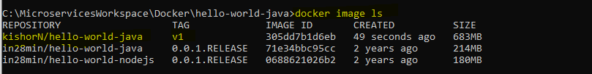

To start instance of image or creates container of image

docker run -d -p 5000:5000 kishorN/hello-world-java:v1



**2) Creating image with Multi Stage Dockerfile:**

FROM maven:3.8.6-openjdk-18-slim AS build

WORKDIR /home/app

COPY . /home/app

RUN mvn -f /home/app/pom.xml clean package

FROM openjdk:18.0-slim

EXPOSE 5000

COPY --from=build /home/app/target/*.jar app.jar

ENTRYPOINT [ "sh", "-c", "java -jar /app.jar" ]

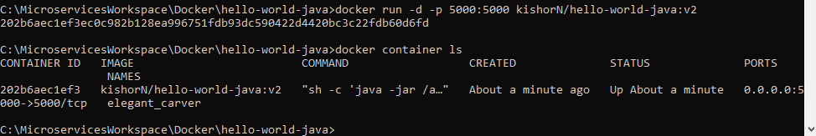

**3) Improve Layer Caching**

FROM maven:3.8.6-openjdk-18-slim AS build

WORKDIR /home/app

COPY ./pom.xml /home/app/pom.xml

COPY ./src/main/java/com/in28minutes/rest/webservices/restfulwebservices/RestfulWebServicesApplication.java /home/app/src/main/java/com/in28minutes/rest/webservices/restfulwebservices/RestfulWebServicesApplication.java

RUN mvn -f /home/app/pom.xml clean package

COPY . /home/app

RUN mvn -f /home/app/pom.xml clean package

FROM openjdk:18.0-slim

EXPOSE 5000

COPY --from=build /home/app/target/*.jar app.jar

ENTRYPOINT [ "sh", "-c", "java -jar /app.jar" ]

